Health, Medicine, Dentistry and Human Sciences

This guide is for students in Health, Medicine, Dentistry and Human Sciences beginning their course in 2019 who may be eligible to claim Recognition of Prior Learning (RPL) You will either be a year 1 student or a degree apprentice/direct entry into year 2 student. You will be entering the required information into the University of Plymouth Open Learning platform.

Accessing the APEL MAPPING Open Learning platform
- To access the APEL MAPPING open learning course please visit the following URL in your web browser:
https://open.plymouth.ac.uk/course/view.php?id=81
You will be presentered with the following screen:
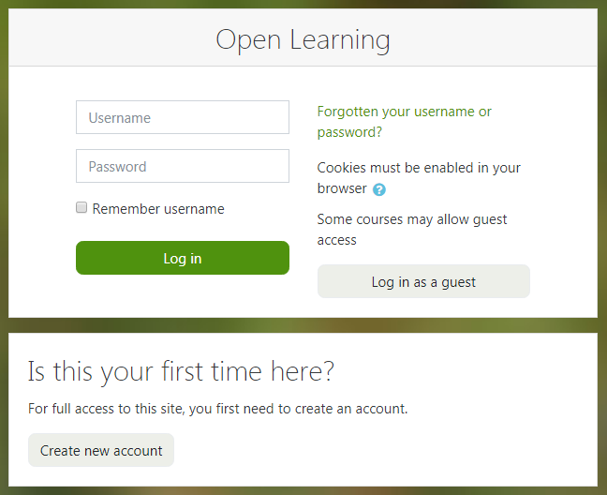
- Click on the button that says ‘Create new account’
Note:
If you have already signed up to the Open Learning platform and are returning to the site you can enter the username and password you signed up with and click the ‘Login’ button.
- On the new account screen enter a username and password of your choice along with information required (indicated by a red exclamation mark !)
- Once you have entered your information click the ‘Create my new account’ button.
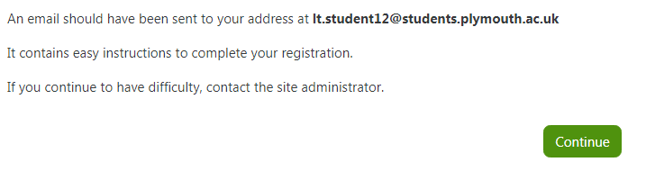
You will then be sent an email to confirm you account. Please click the link in this email to confirm your account and complete your registration on the Open Learning platform.
Note: If you cannot find the email please check your Junk or spam folder.
- When you click the link in your email you will be presented with the screen below. Click the ‘Continue’ button
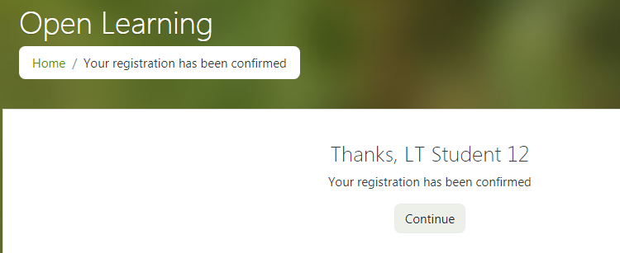
- You will then see the following screen. Click on the ‘Enrol me’ button for the APEL MAPPING.
- 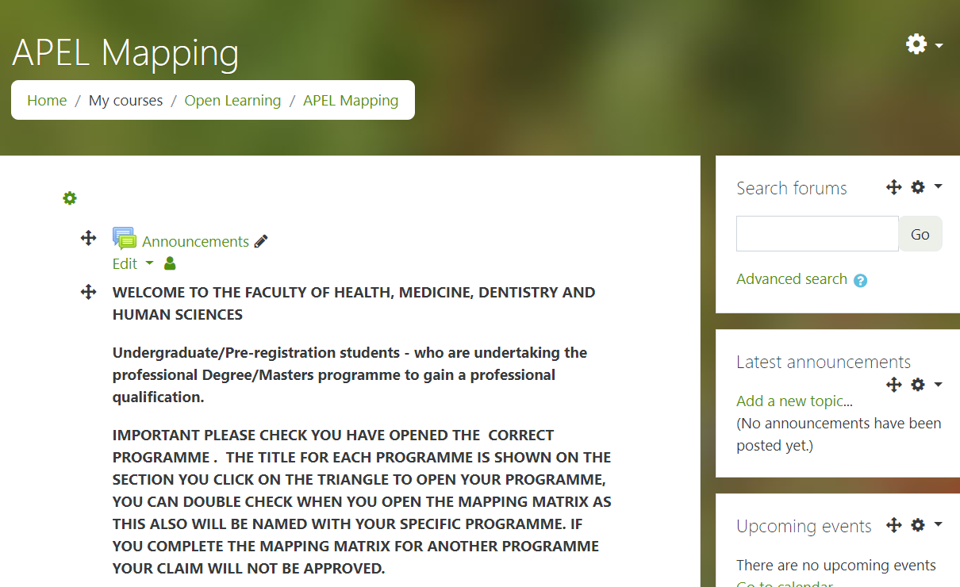
Note: if for any reason you do not see the screen above please revisit: in your web browser. You may be prompted to sign in with the username and password you signed up with in step 3.
https://open.plymouth.ac.uk/course/view.php?id=81
- You will now be able to access and complete the required Mapping Matrix for your programme of study. To open your section click on the triangle you will then be able to access the information relevant to your programme of study.
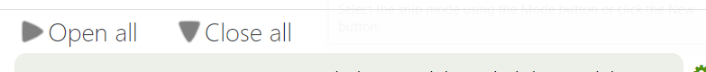
IMPORTANT – You must check you have opened the correct programme as the named mapping matrix will have the relevent modules for your programme. If you completet the wrong matrix your claim will be invalidated.

Completing the forms
- Complete all the questions on the Mapping Matrix for your programme answering either YES or NO.
- If you answer yes in the next box please add the module and learning outcome that you consider matches the learning outcome of the module.
- Each module will have 3 – 6 questions (Learning Outcomes) all of which need to be met in order to make a claim.
- Once you have completed the Matrix you can then click on the section below following the instructions.
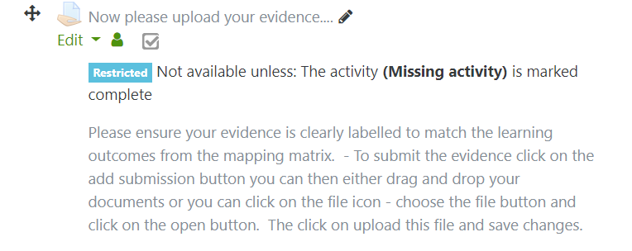
- If you are claiming for any Practice you MUST provide a transcript from your previous University/College verifying the hours and competencies achieved.
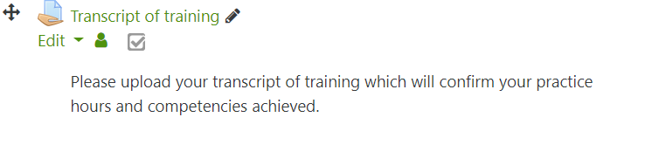
- You can return to the APEL Mapping home page at any time by clicking on the ‘APEL Mapping’ link in the breadcrumbs trail at the top of the page.

