 | Pupil Passport
 | Name
 | Preferred name
 | DOB
 | Current setting
Next setting
(in order of preference)
5 Things that help me cope with stress and worries
(You don’t have to come up with 5 things – write what you can)
1.
2.
3.
4
5.

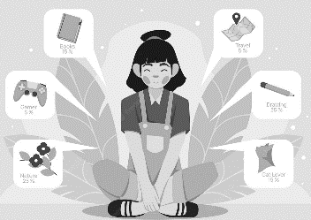 |  | 5 things I would like my college to know about and support me with  (You don’t have to come up with 5 things – write what you can)  1.  2.  3.  4  5.
People who are important to me.
(You don’t have to come up with 5 things – write what you can)
1.
2.
3.
4
5.

I prefer to communicate by….
(Text, phone call, face to face, email, virtual meeting, speaking to someone who is important)

I’m happy to share this information with professionals to help and support me  Signature:  Date: |  |  |  | Yes  ☐ | No  ☐

